We have a PC with Windows 10 that consists of two groups: Vocational and Secondary. The user “VocationalUser” will belong to “Vocational” and the user “SecondaryUser” will belong to “Secondary”. There is also a user called Teacher which belongs to the group Administrators.

Complete all the exercises considering two scenarios: disabling inheritance and with inheritance.

**1.** Create all the users and groups mentioned above.

--> We go to Computer Management>Local Users and Groups>Users/Groups>More Actions>New user/new group

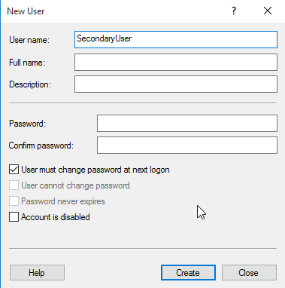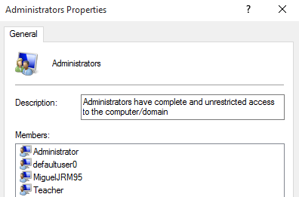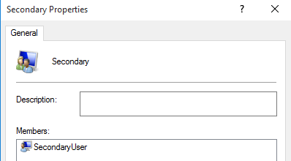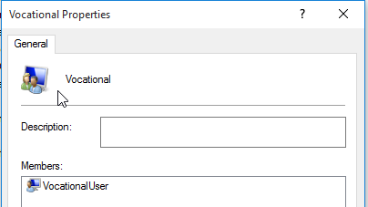

**2**. Create the following directory tree with the permissions below.



a. The directory known as “Shared” is able to be accessed by two users: “VocationalUser” and “SecondaryUser”, but they cannot delete or create subfolders and files. The user Teacher has Full Control over this directory.

--> We need to disable inheritance in "Shared" folder to assgn independent permissions

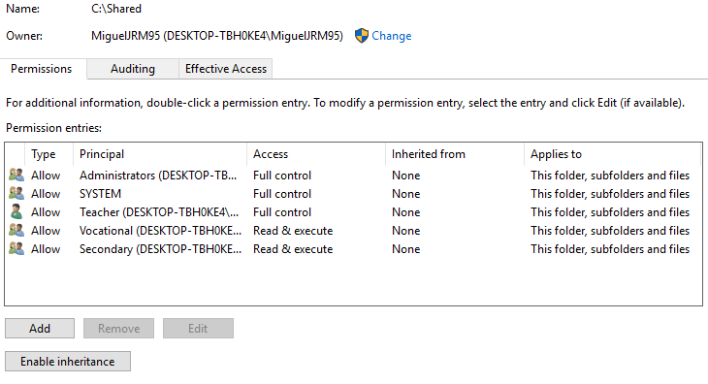

b. The directory “For secondary” cannot be accessed by the group “Vocational”, while the group “Secondary” is able to do everything except change permissions.

* Without inheritance

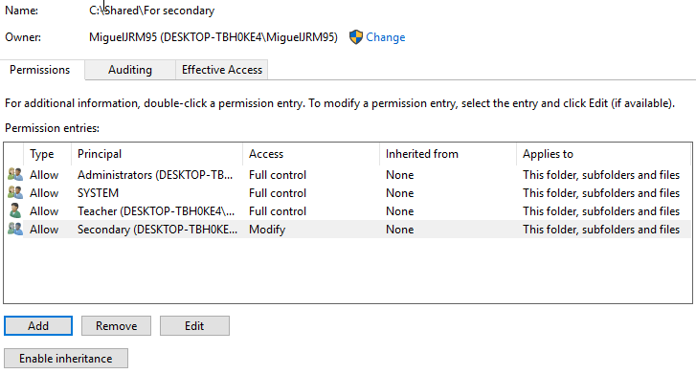

* With inheritance

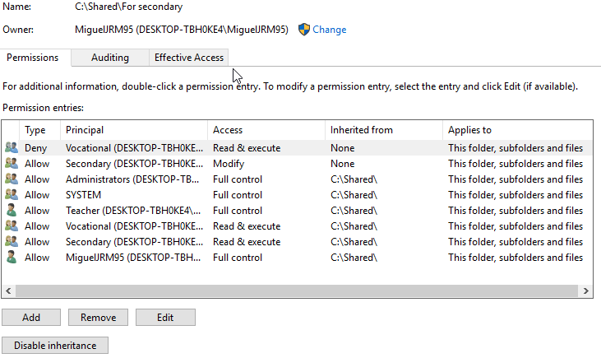

c. The directory “For vocational” cannot be accessed by the group “Secondary”, while the group “Vocational” is able to do everything except delete this folder and change permissions.

* Without inheritance

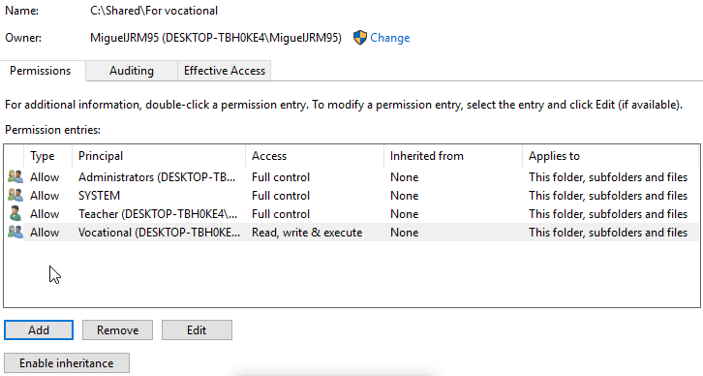

* With inheritance

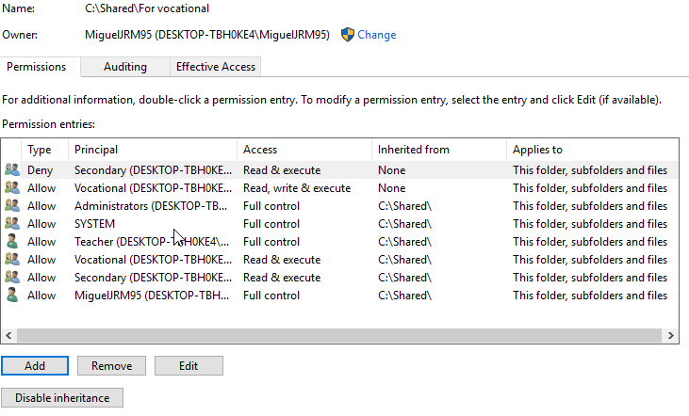

d. The directory “Only for students” can be accessed exclusively by all students regardless of the group. They will able to create files within this folder.

--> We are going to use advanced permissions for Vocational and Secondary groups even with inheritance and without it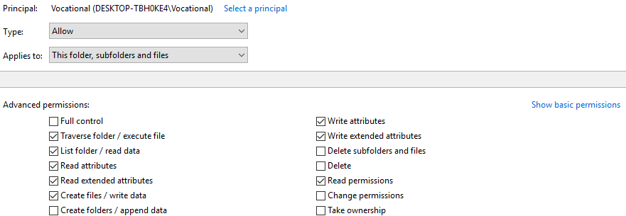

* Without inheritance

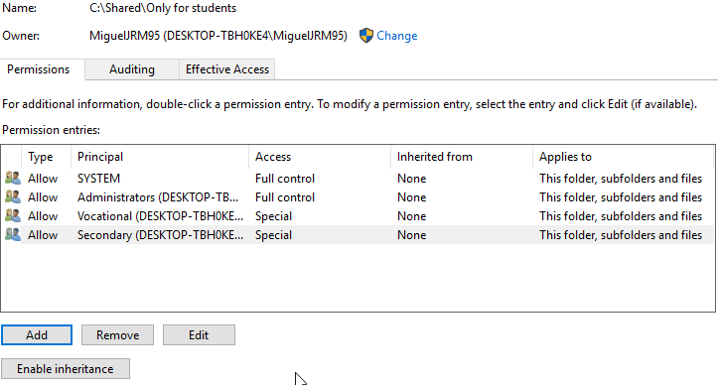

* With inheritance

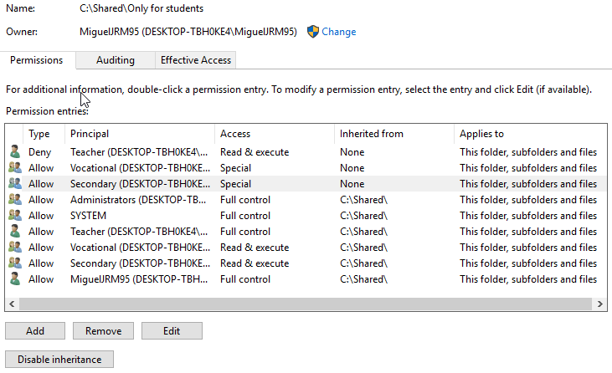

e. The directory “Only for teachers” can be accessed exclusively by all teachers and only with read and execute permissions.

* Without inheritance

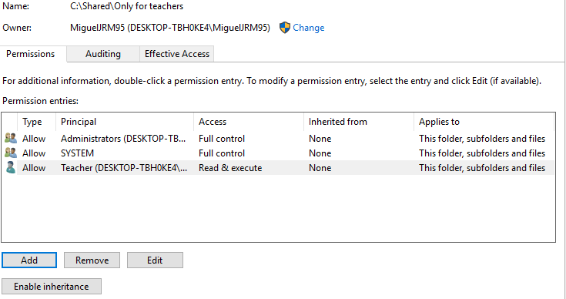

* With inheritance

